FOSTERING REMITTANCE SLIPS EXPAINED
Fostering payments are made on a fortnightly basis via BACSthis runs from a Sunday to a Saturday.
Payment is made into your bank on the Friday before the last Saturday of the pay period, i.e.
- Pay period Sunday 17th December ‘23 – Saturday 30th December ‘23
- Pay date Friday 29th December ’23 (Fortnightly thereafter)
The remittance slip creates 2 lines for each payment covering the 2-week period, therefore if you are a carer who receives a fee, level 2 - 4 you will see 4 lines for each child. If back pay is applicable, there will be extra lines to accommodate this. Please check to ensure the start date matches the date the child was placed (unless un-regulated for a period)
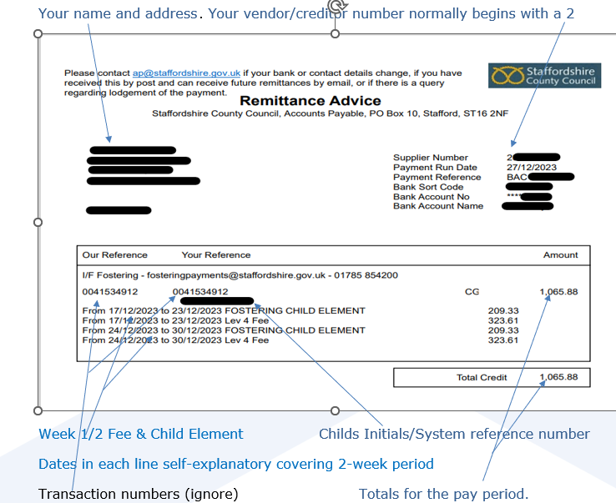

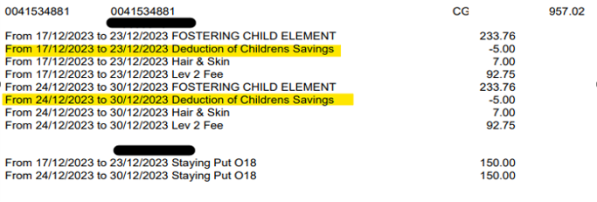The above shows the deduction of the new saving scheme for children. Also, Hair & Skin payment some carers can claim (please refer to Fostering Handbook for entitlement) and Staying Put payments
Recoupment for overpayment of allowances.
This will normally show the date the placement ceased completely; we are unable to use the 1st date the overpayment starts from due to service closure. This may not be the full amount you have been overpaid; it will be subject to funds available. You should be able to calculate any overpayment via the remittance the overpayment occurred in.

Child discharged 11/12/23 – the system has automatically repaid/recouped any savings already deducted before discharge known and the Festive allowance that had been paid in lieu of 25th December.

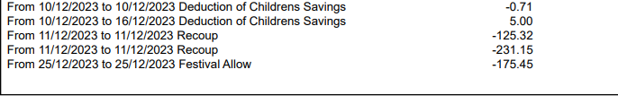
This shows a recoupment with actual dates the overpayment was made. This is only a short break overpayment, not end of placement, funds were available, and the service continues. Short break was 17/11-09/12/23 – we have recouped 18/11-08/12. Again 2 lines for fee and child element.
Both carers are paid for 17/11 and 09/12 – standard process for all short breaks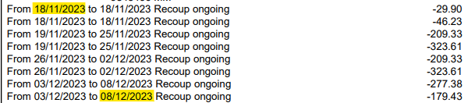

Mileage and discretionary payments do not show any narrative. You should always keep a record of amount spent and dates claims are submitted. Equipment may not be allocated to a child (please refer to Fostering Handbook for entitlement).
Wherever possible we will use the closest date to the narrative on the form the social worker has submitted for processing. If payment was for a full month, we will use the end date of that month
Some specialised carers receive a fee, below shows some different types of payments the Local Authority (LA) make, again payments are split into the 2 weeks’ pay period and split into personal allowance and clothing element – this equates to the full child element, age related all carers receive.
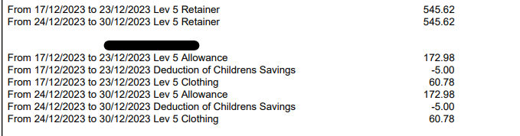
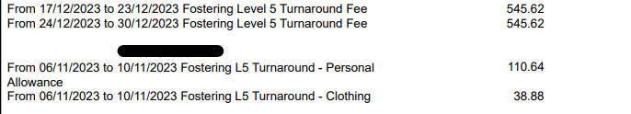

Some carers may receive payments for other services provided such as orderpayments/special guardianship/adoption/foundations etc... this should show on one remittance. Adoption will not have child’s initials or reference number.
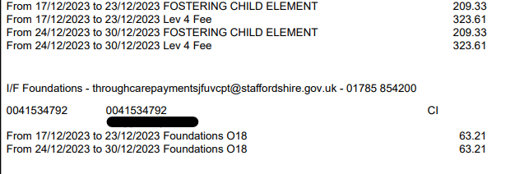
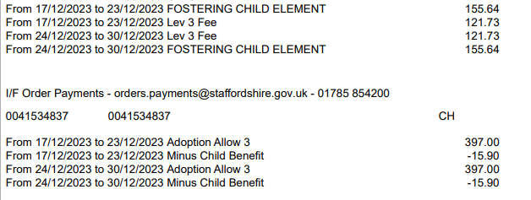
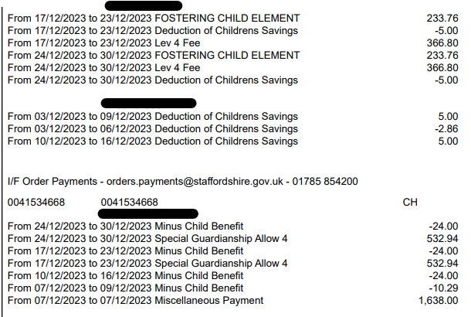

The expectation is for all carers to check their remittances every fortnight and be aware of incorrect payments including over or under payments. If your payment is incorrect, please contact your Supervising Social Worker in the 1st instance.
*** Please remember the recommendation is to retain these remittance slips for a period of 6 years***

